**VIETNAM NATIONAL UNIVERSITY, HO CHI MINH CITY**

**UNIVERSITY OF TECHNOLOGY**

**FACULTY OF COMPUTER SCIENCE AND ENGINEERING**



**SOFTWARE ENGINEERING ASSIGNMENT**

**PROJECT: UWC 2.0 (TASK 2)**

**CC02 --- GROUP HÍ HÍ HÌ HÌ --- SEM 221**

**SUBMIT: 10/11/2022**

**INSTRUCTOR: PROF. ĐỨC ANH**

|  |  |
| --- | --- |
| **Students’ name** | **Student’s ID** |
| Nguyễn Viết Hòa | 2052486 |
| Trần Gia Linh | 2053182 |
| Nguyễn Mỹ Khanh | 2052525 |
| Trần Ngọc Oanh | 2053312 |
| Phạm Thị Thái Minh | 2052174 |

**Ho Chi Minh City – 2022**

**Contents**

TASK 2: SYSTEM MODELING 3

1 ACTIVITY DIAGRAM 3

1.1 ACTIVITY DIAGRAM 3

1.2 DESCRIPTION 4

2 CONCEPTUAL SOLUTION_SEQUENCE DIAGRAM 5

2.1 SEQUENCE DIAGRAM 5

2.2 CONCEPTUAL SOLUTION 5

3 CLASS DIAGRAM 7

3.1 CLASS DIAGRAM 7

3.2 DESCRIPTION 8

# TASK 2: SYSTEM MODELING

# ACTIVITY DIAGRAM

## ACTIVITY DIAGRAM

## DESCRIPTION

* The system will be initiated by back officers.
* When they open the application, they will send a request to the system to view the calendar, then the system will display the requested calendar, which consists of the current calendar, tasks and vehicles,...
* After viewing the calendar, back officers can start to update the calendar by choosing a date, the system then will display available tasks on that day and allow the back officers to assign them.
* The back officers then will be allowed to view the information of those tasks (including information about description, workers, vehicle, MCPs, areas,.. ). Back officers will be able to choose from a list of workers and assign the appropriate person for the jobs.
* The system will check for the worker’s type. If it is a collector, back officers can then check information about available vehicles and assign them to the worker and then move on to the area assigning part. If it is not a collector, then the system will move to an area assigning part without vehicle assigning.
* After officers have assigned areas for workers, the system will then optimize routes if workers are collectors and have vehicles. Then it will show the routes to the back officers for them to confirm.
* After areas are assigned and routes are optimized, the system will update the calendar, display the calendar to back officers and ask for their confirmation.
* Back officers can then view and confirm the updated calendar and finish their jobs and log out.

# CONCEPTUAL SOLUTION_SEQUENCE DIAGRAM

## SEQUENCE DIAGRAM

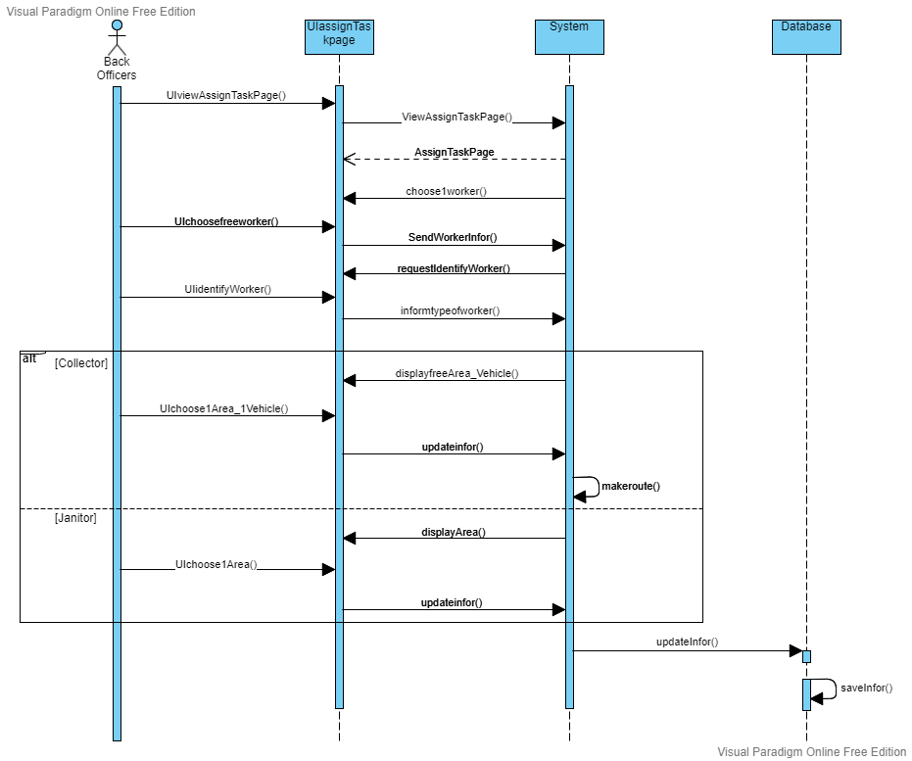

## CONCEPTUAL SOLUTION

* In this function, the user will go through the UI to ask the system to display the Assign Task page.
* The system receives the request and then returns to the Assign Task page
* The system asks the UI to display a menu containing a list of workers who are free for the day.
* The user goes through the menu to select a worker and sends the worker information to the system through the UI.
* The system receives the information and asks the UI to show 2 options (collector/janitor).
* The user defines the worker’s type.
* The UI sends the selection information to the system.
* If the option is “Collector”:
* The system will ask the UI to show a menu with a list of uncollected areas and vehicles that are free for the day.
* The user, through the UI, selects 1 or more regions and 1 vehicle from the list.
* UI sends information back to the system.
* The system relies on the information about which areas to generate the shortest route.
* If the option is “Collector”:
* The system will ask the UI only to show a selection list of areas.
* The user, through the UI, selects 1 area.
* The system sends information back to the database.
* Database updates new task information.

# 

# CLASS DIAGRAM

## CLASS DIAGRAM

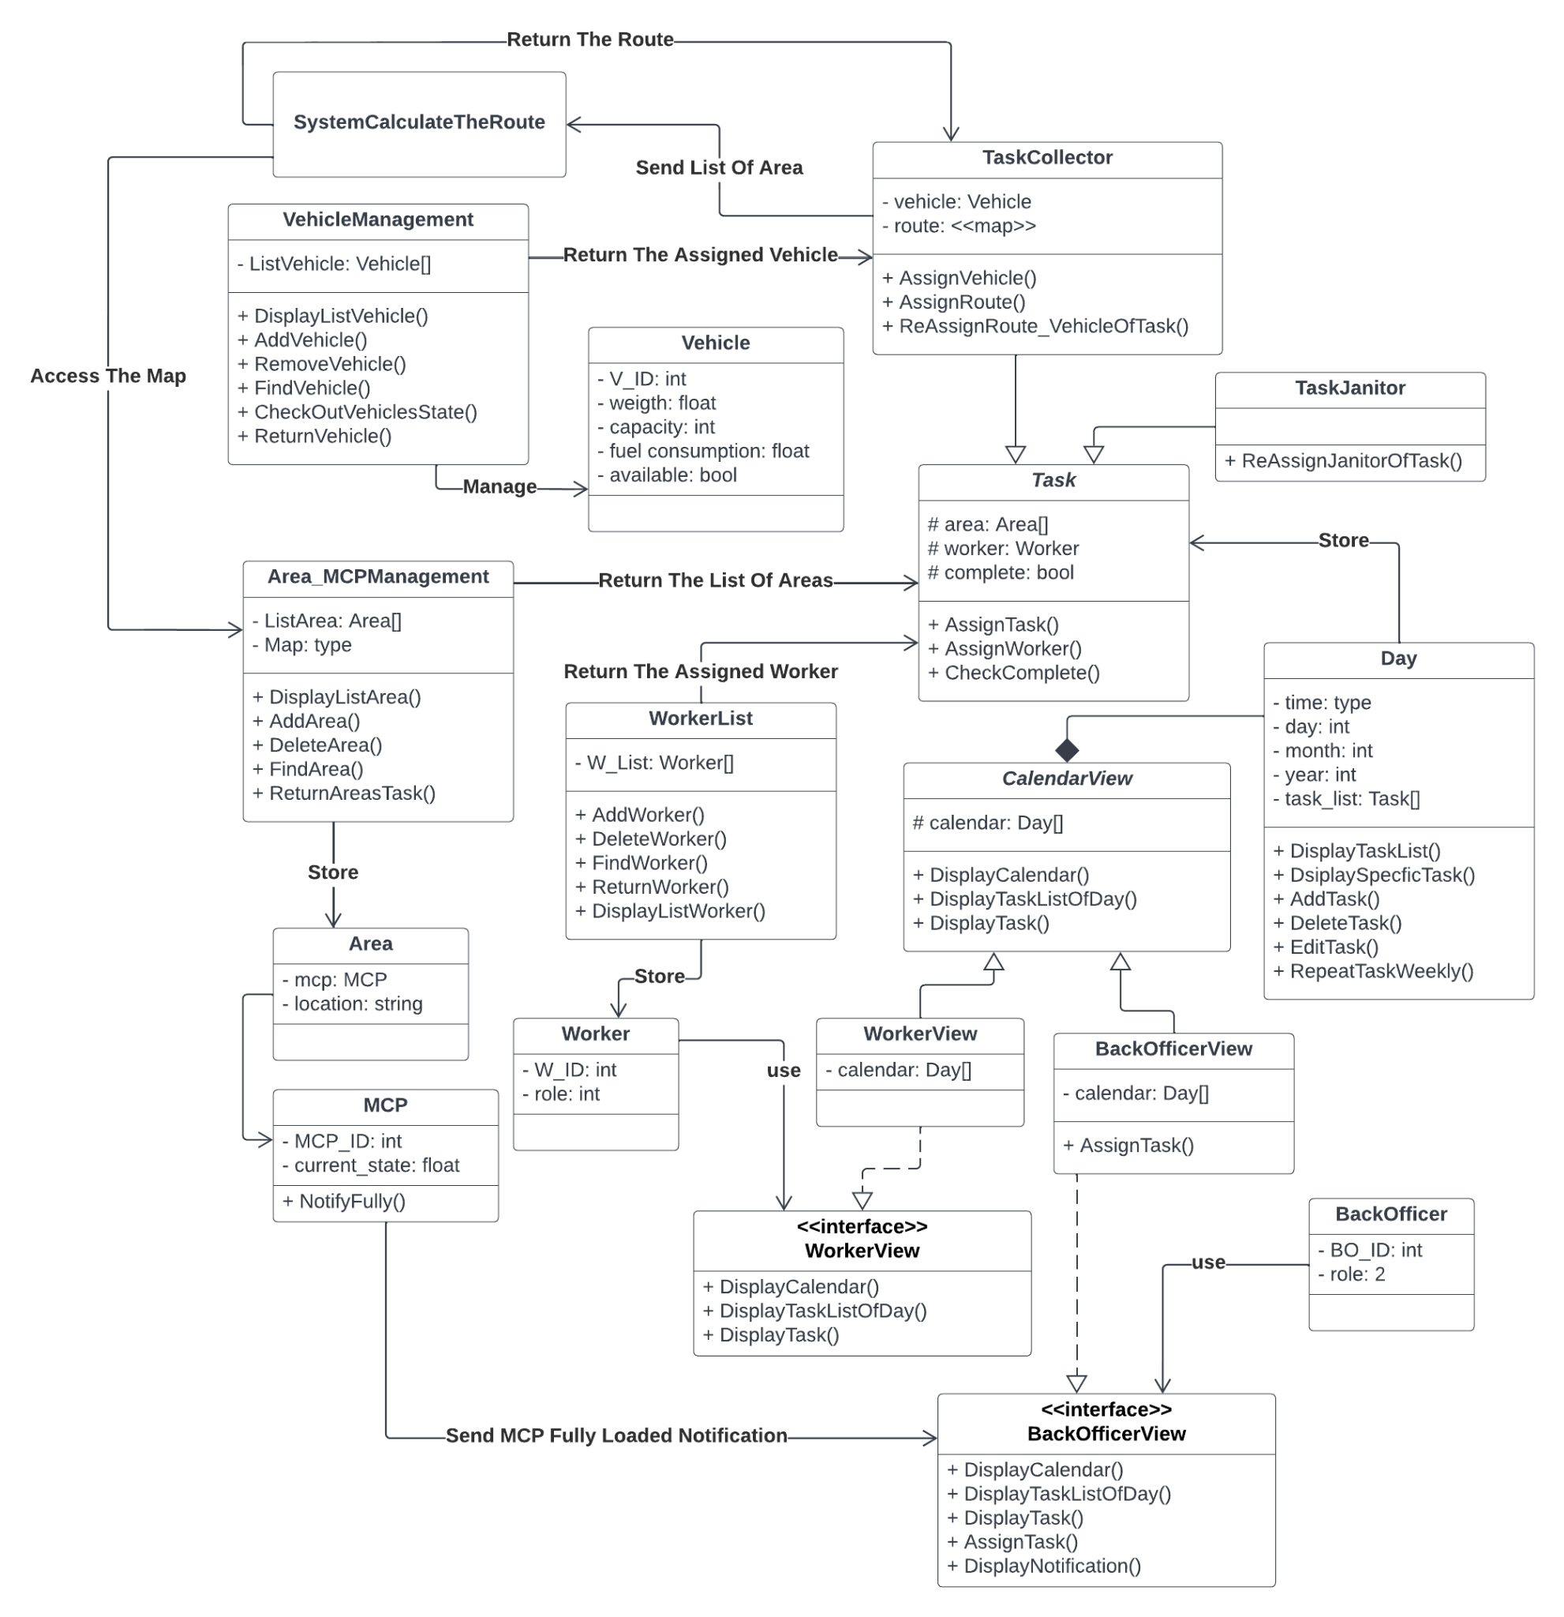

## DESCRIPTION

* Workers and Back Officers can interact with the system through their interfaces which are *WorkerView* and *BackOfficerView*.
* The Back Officer can assign new Tasks through the Calendar in the interface.
* The Back Officer will assign the Task with the Worker from the *WorkerList* and the Area(s) that Worker will be in charge from the *Area_MCPManagement*. With different kinds of Worker (*Collector* and *Janitor*), the Task will have more things to assign.
* The Back Officer can re-assign the Janitor for a Task weekly via *ReAssignJanitorOfTask()*.
* For the Collector, the Back Officer needs to assign the Vehicle used for the task from the *VehicleManagement*, then, assign the Route for that task which is calculated by the System.
* The Back Officer can also re-assign the Route and the Vehicle used for a Task monthly.
* When the users choose a specific day in the Calendar, the list of the tasks of that day will be displayed. After a specific task is chosen, the information of that task will be shown on the screen including what the Back Officer has assigned.

**END OF REPORT**

_________________________________